Employee management system using SQL

**Objective-**

* Give employees the smooth access to view and edit their stats online
* Providing various tables like department, projects
* Providing login credentials to have all the data stored for a user.
* Providing strong Admin Controls to control the data that appears on the website

**Abstract**

Everything has been computerised in our age of ever-increasing technologies. The Human workforce has grown as a result of the abundance of career opportunities. As a result, a system that can handle the data of a large number of employees in an organisation is required. Because of its user-friendly design, this project makes maintaining records easier.

Employee Management System is a website, developed to maintain the details of employees working in any organization. It maintains the information about the personal details of their employees, also the details about the projects and departments they are assigned to. The application is actually a collection of web pages made using HTML, CSS and the functionalities made using Javascript. Nodejs helps in serving the pages from a server and SQL stores the database and runs queries to give us the required data easily and efficiently.

Tools used-

Languages used-

-Html-

HTML, or HyperText Markup Language, is the standard markup language for documents that are intended to be viewed on a web browser. Technologies such as Cascading Style Sheets and scripting languages like JavaScript can be used along with HTML.

-CSS

Cascading style sheet used for aesthetics and layout of the page.

-JavaScript

JavaScript, also known as JS, is a programming language that, together with HTML and CSS, is one of the essential technologies of the World Wide Web. On the client side, over 97 percent of websites employ JavaScript for web page behaviour, with third-party libraries frequently incorporated. Its used for making our website appear interactive and dynamic.

* Handlebars

Handlebars is nothing but a template engine used with Node js.

Template engine

Template engines are used when you want to rapidly build web applications that are split into different components. Templates also make it possible to render the server-side data that must be given to the application quickly. Eg. You might want to include elements like the body, navigation, footer, dashboard, and so on.

Why handlebars-

* It keeps your HTML page clean and separates the logic-less templates from the business logic in your JavaScript files, thus improving the structure of the application (and also its maintainability and scalability)
* It simplifies the task of manually updating the data on the view

• Database used –

• MY SQL-

MySQL is an open source relational database management system (RDBMS) based on Structured Query Language that is backed by Oracle (SQL). MySQL is available on almost any platform, including Linux, UNIX, and Windows. MySQL is most commonly linked with web applications and online publishing, despite the fact that it may be utilised in a wide range of applications.

Why My SQL-

* Open source
* Flexible
* Scalability
* Fast and efficient
* Round the clock uptime

• Visual Studio code.

• It consists of:

• a Node.js server.

• a JavaScript client library for the browser (which can be also

run from Node.js).

Backend –

Node.js - Node.js is an open-source, cross-platform, backend JavaScript runtime environment that runs on the V8 engine and executes JavaScript code outside a web browser.

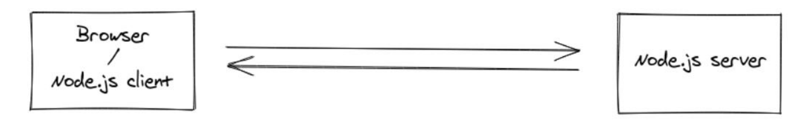

-For the backend server establishment we used Node js and connected the Sql with that only using Xampp.

Xampp

XAMPP is an acronym that stands for Cross-Platform, Apache, MySQL, PHP, and Perl, with the Ps standing for PHP and Perl, respectively. It's an open-source web-solutions package that includes Apache distribution for a variety of servers and command-line executables, as well as Apache server, MariaDB, PHP, and Perl modules.

Before publishing a website or client to the main server, XAMPP allows a local host or server to test it on computers and laptops. It is a platform that provides a suitable environment for testing and verifying the functionality of projects based on Apache, Perl, MySQL, and PHP using the host's system.

Website interface

Login page

* Here a user enters its email password and username to log in

Or he can sign up for the website

Home page

* Here one can view the employee table and also has links for departments and projects table.
* Here one can also view edit and delete records .
* We can also add a new employee in the table on this page

Department page

* Here one can view the department tables and view edit and delete department records

Projects

* Here we can see the project table and view edit and delete project records

Dbms used-

We add a database using Xampp in which we have following tables-

Login table

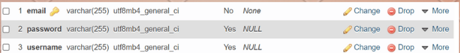

create table login(

email varchar(255) primary key,

password varchar(255)

username varchar(255));

Employee table

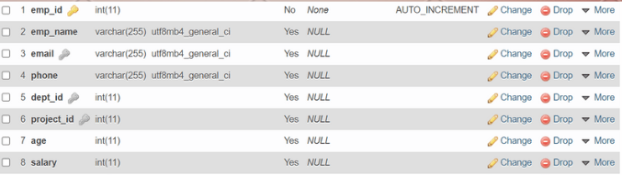

create table employee(

emp_id int primary key,

emp_name varchar(255),

email varchar(255),

phone varchar(255),

dept_id int,

project_id int,

age int,

salary int,

emp_image longblob,

foreign key(email) references login(email),

foreign key(dept_id) references department(dept_id),

foreign key(project_id) references project(project_id));

Department table

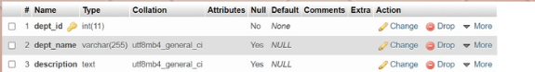

create table department(

dept_id int primary key,

dept_name varchar(255),

description text);

Project table

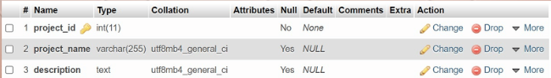

create table project(

project_id int primary key,

project_name varchar(255),

description text);

Er diagram

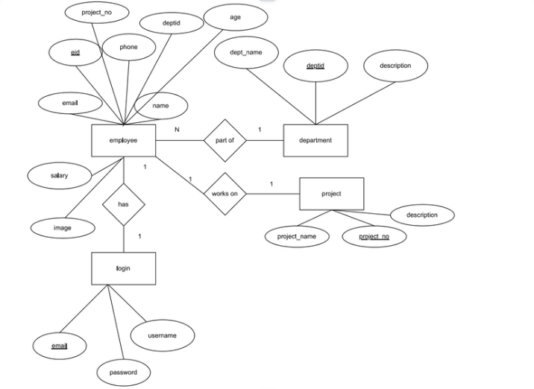

Relations and foreign keys-

* Employee table has email which is foreign key that relates to email of login table
* Employee table has dept_id that which is foreign key that relates to dept_id of department table
* Employee table has project_no which is foreign key that relates to project_no of project table.

Queries used-